Logging
The BUG mod includes a logging portion that logs the general events that occur in the game to a text file. This is mainly included for succession game (SG) players as a way of recording the mundane events that occur. Typically, SG players / events have house rules concerning the use (or otherwise) of loggers.
The options shown on the BUG mod’s logging option screen are shown below.
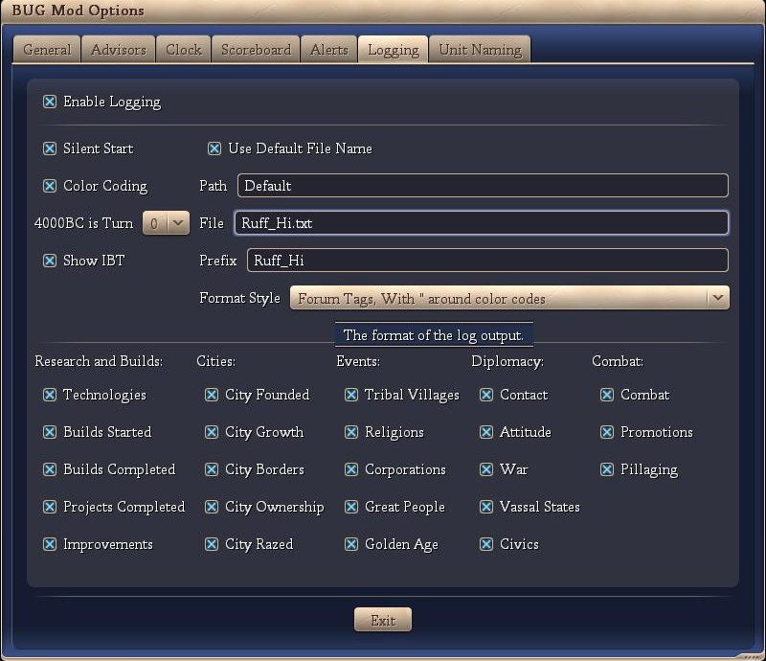
These features are discussed below:
- Enable Logging
If this options is checked, then the logging portion of BUG is enabled and logging will occur. If this options is not checked, then the logging portion of BUG is not enabled and logging will not occur.
- Silent Start
This option means that logging of the game will automatically start and the file name will be set to the name of the player. In the above graphic, the game was started by the player ‘Ruff_Hi’ and the logging will be written to a file ‘Ruff_Hi.txt’ that is in the default file path (my docs\BtS\autolog).
- Color Coding
If color coding is checked, then the log will include various color characteristics that group the events being logged by color. The user cannot adjust the colors.
- 4000BC is turn ?
The logger includes code to count 4000BC as Turn 0 or Turn 1. The user can specify which counter they wish to use.
- Show IBT
If this option is checked, then the logger will include a line that contains “IBT:” at the conclusion of the players turn and prior to the AIs turns.
- Use Default File Name
If ‘Silent Start’ is not checked, then the player must start the logger manually. The key to start the logger is Alt-L. If the ‘Use Default File Name’ option is checked, then the default name (Player’s Name) is used for the text file. If the ‘Use Default File Name’ option is not checked, then the player must supply a file name via an input box.
- Path
The player can over-ride the default path for the location of the logging file.
- File
The player can over-ride the default file name.
- Prefix
The player can manually add a comment to the log file (Alt-E). The logger records this manual entry with the addition of the ‘Prefix’.
- Format Style
There are four (4) format styles available for the log file. None: no formatting, HTML: html tags are included, Forum with ‘“’: Forum tags with ‘“’s around the color text (if any) are included, Forum without ‘“’: Forum tags without ‘“’s around the color text (if any) are included.
- Research and Builds
  - Technologies
If checked, technologies gained through research or trade are logged, Technologies started are logged together with the game’s estimate of the number of turns to complete.
  - Builds Started
If checked, city builds (either buildings, wonders or units) started are logged together with the game’s estimate of the number of turns to complete
  - Builds Completed
If checked, city builds (either buildings, wonders or units) completed are logged.
  - Projects Completed
If checked, city builds (projects) completed are logged.
  - Improvements
If checked, city improvements (cottages, farms, mines, etc) are logged.
- Cities
  - City Founded
If checked, cities founded are logged.
  - City Growth
If checked, city growth is logged.
  - City Borders
If checked, city border expansions are logged.
  - City Ownership
If checked, city ownership, or change in ownership, is logged.
  - City Razed
If checked, city destruction is logged.
  - City Whipped
If checked, rushing the build queue via whipping is logged as well as when the city whip anger decreases.
- Events
  - Tribal Villages
If checked, the result from tribal villages is logged.
  - Religions
If checked, the founding or spread of religions is logged.
  - Corporations
If checked, the founding or spread of corporations is logged.
  - Great People
If checked, the birth of Great People is logged.
  - Golden Age
If checked, the start and end of Golden Ages are logged.
- Diplomacy
  - Contact
If checked, initial contact between the player and other civilizations is logged.
  - Attitude
If checked, attitude changes between known civilizations is logged.
  - War
If checked, the war status between known civilizations is loggedError: Reference source not found.
  - Vessel States
If checked, the vessel state status between known civilizations is loggedError: Reference source not found.
  - Civics
If checked, civic changes of known civilizations are logged.
- Combat
  - Combat
If checked, combat between the player’s units and units from another civilization is logged Also logged are the results, general location, victory probability and remaining health of the victorious unit.
  - Promotions
If checked, promotions granted to the player’s units are logged.
  - Pillaging
If checked, pillaging performed by the player’s units regardless of location or pillaging by the AI units on the player’s tiles, is logged.

The following is a sample of a typical log file.
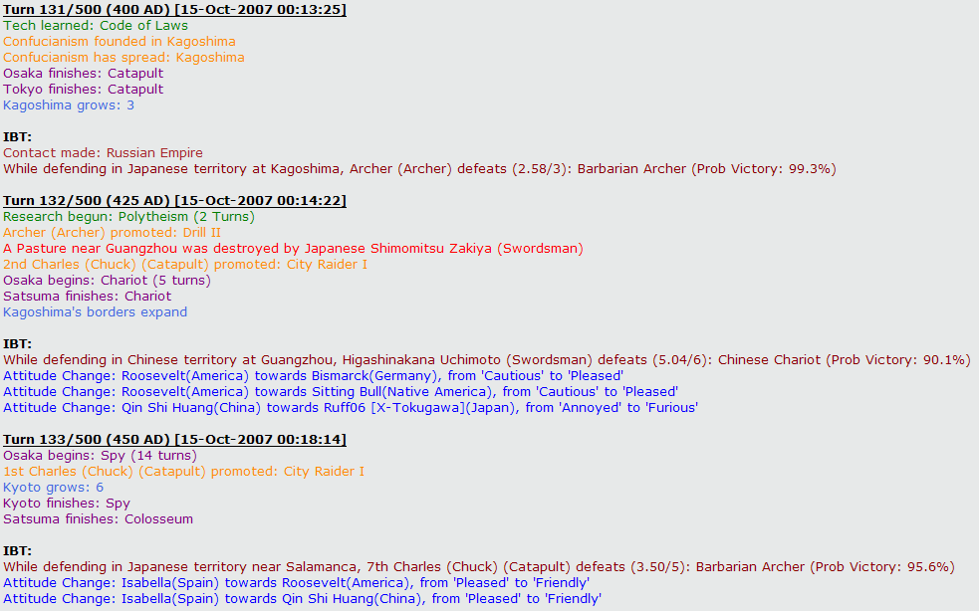

IBT stands for “In between Turns”.
Note: Both civilizations must be known to the player.

